**GIRIJANANDA CHOWDHURY UNIVERSITY, ASSAM**

**Question bank**

**Data Interpretation questions**

**Multiple-choice questions (MCQs)**

1. **Question** : Tabular Data Interpretation

Month Sales (in thousands) Expenses (in thousands)

January 120 80

February 140 90

March 160 95

April 180 100

Question:

1. What was the net profit in February?

- A) 30 thousand

- B) 50 thousand

- C) 60 thousand

- D) 70 thousand

**2: Percentage Calculation**

Age Group Number of Participants

0-10 25

11-20 40

21-30 55

31-40 45

41-50 30

Question:

What percentage of participants belongs to the age group 11-30?

- A) 25.64%

- B) 38.46%

- C) 48.72%

- D) 56.41%

**3 Question**: Pie Chart Interpretation

Percentage Distribution of Expenses

Rent 30%

Utilities 20%

Salaries 40%

Others 10%

Question:

What percentage of expenses does salaries represent?

- A) 10%

- B) 20%

- C) 30%

- D) 40%

4 **Question: Average Calculation**

Week Number of Customers

1 120

2 150

3 100

4 180

What was the average number of customers per week?

- A) 125

- B) 137.5

- C) 150

- D) 180

**5 Question:** Ratio Calculation

Boys Girls

15 20

Question:

What is the ratio of boys to girls?

- A) 2:3

- B) 3:2

- C) 4:5

- D) 5:4

**6 Question**: Percentage Increase

Year Sales (in millions)

2019 100

2020 120

Question:

What was the percentage increase in sales from 2019 to 2020?

- A) 10%

- B) 15%

- C) 20%

- D) 25%

**7 Question**: Percentage Decrease

Initial Value: 500

Final Value: 450

Question:

What was the percentage decrease in value?

- A) 8%

- B) 9%

- C) 10%

- D) 11%

**8 Question** : Tabular Data Interpretation

Year Revenue (in thousands) Expenses (in thousands)

2018 200 150

2019 220 160

2020 240 170

2021 260 180

Question:

What was the net profit in 2020?

- A) 60 thousand

- B) 70 thousand

- C) 80 thousand

- D) 90 thousand

**9 Question:** Percentage Calculation

Age Group Number of Participants

0-10 20

11-20 35

21-30 50

31-40 40

41-50 25

Question:

What percentage of participants belongs to the age group 21-40?

- A) 38.46%

- B) 45.12%

- C) 56.41%

- D) 64.10%

**10 Question: Percentage Distribution of Expenses**

Rent 25%

Utilities 30%

Salaries 35%

Others 10%

Question:

What percentage of expenses does utilities represent?

- A) 15%

- B) 25%

- C) 30%

- D) 35%

**11 Question**: Average Calculation

Month Number of Orders

January 150

February 180

March 120

April 200

What was the average number of orders per month?

- A) 162.5

- B) 162

- C) 170

- D) 175

**12 Question**: Ratio Calculation

Men Women

30 45

Question:

What is the ratio of men to women?

- A) 3:5

- B) 5:3

- C) 2:3

- D) 3:2

**13 Question**: Percentage Increase

Year Sales (in millions)

2019 150

2020 180

What was the percentage increase in sales from 2019 to 2020?

- A) 10%

- B) 15%

- C) 20%

- D) 25%

**14 Question: Percentage Decrease**

Initial Value: 800

Final Value: 720

What was the percentage decrease in value?

- A) 8%

- B) 9%

- C) 10%

- D) 11%

**DIRECTIONS *for questions 15 &16:*** Study the following graph and answer the questions that follow.  
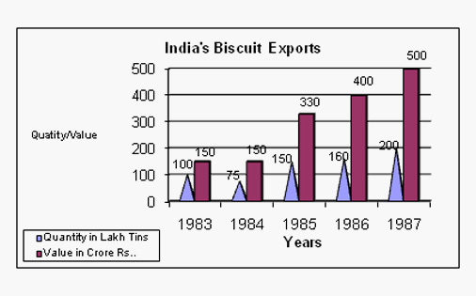

1. **Question:** In which year was the value per tin the minimum?

A. 1987

B. 1984

C. 1985

D. 1986

E. 1983

1. **Question:** If in 1986 tins were exported at the same rate per tin as in 1985, then what would be the value of exports in 1986? (Crores of Rupees)

A. 400

B. 420

C. 375

D. 330

Answer the questions (17 to 19) based on the following table:

|  |  |  |  |
| --- | --- | --- | --- |
|  | **Football** | **Basketball** | **Total** |
| **Amateurs** | 40 | 46 | 86 |
| **Professionals** | 52 | 60 | 112 |
| **Total** | 92 | 106 | 198 |

1. **Question:** Calculate the fraction of amateurs who play basketball amongst the total players?
2. 0.132
3. 0.333
4. 0.213
5. 0.202
6. 0.102

18 **Question:** Calculate the ratio of professional football players who are professionals to the total number of players?

1. 26/99
2. 15/78
3. 13/31
4. 24/55
5. 27/88

**19 Question:** If there are x percent more amateurs players than are professionals, what is x?

1. 0.218
2. 0.356
3. 0.123
4. 0.302
5. 0.234

**20 Question:** Average Calculation

Month Number of Orders

January 150

February 180

March 120

April 200

What was the average number of orders per month?

- A) 162.5

- B) 162

- C) 170

- D) 175

**21 Question**: Ratio Calculation

Men Women

30 45

Question:

What is the ratio of men to women?

- A) 3:5

- B) 5:3

- C) 2:3

- D) 3:2

**22 Question:** Percentage Increase

Year Sales (in millions)

2019 150

2020 180

What was the percentage increase in sales from 2019 to 2020?

- A) 10%

- B) 15%

- C) 20%

- D) 25%

**23 Question** Percentage Decrease

Initial Value: 800

Final Value: 720

What was the percentage decrease in value?

- A) 8%

- B) 9%

- C) 10%

- D) 11%

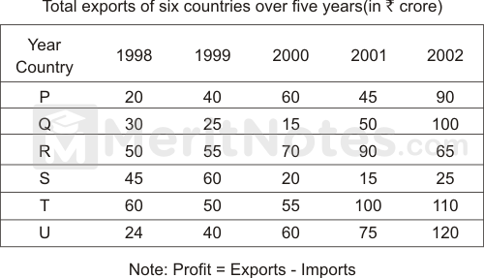

**24 Question**

What was the profit of all the countries together in the year 2002 if the total imports of all the countries together was Rs. 385 crore?

(A) Rs. 85 crore

(B) Rs. 125 crore

(C) Rs. 160 crore

(D) Rs. 280 crore

**25 Question**

If the ratio of export to import in country S and Country U is 1 : 2 and 4 : 1 in the year 1998, then what is the total import of country U and S together in that particular years?

(A) 52

(B) 62

(C) 82

(D) 96

**26 Question**

If the export of country P in the year 2003 is 20% more than the total export of country Q in 2001 and the export of Country T in 2000 together, then what was the profit of P in the year 2003 if its import was Rs. 92 crore for that year?

(A) 10

(B) 22

(C) 34

(D) 46

**27 Question**

What is the percent increase in the export of all the countries together during the year 1992 to 2001?

(A) 38.89%

(B) 40.60%

(C) 62.89%

(D) 72.39%

The following table gives the percentage of marks obtained by 7 students in 6 different subjects in an examination. Study the table and answer the questions based on it.

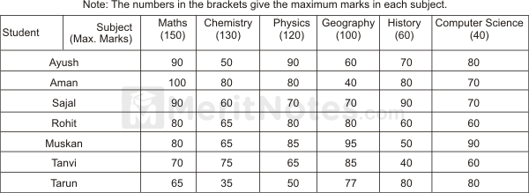

**28 Question**

What was the aggregate of marks obtained by Sajal in all the six subjects?

(A) 429

(B) 439

(C) 449

(D) 459

**29 Question**

The number of students who obtained 60% and above marks in all the subjects is

(A) 1

(B) 2

(C) 3

(D) 4

**30 Question**

What is the overall percentage of Tarun?

(A) 55%

(B) 60%

(C) 63%

(D) 64.5%

**31 Question**

What are the average marks obtained by all the seven students in Physics? (rounded off to two digits after decimal)

(A) 77.26

(B) 79.14

(C) 89.14

(D) 91.37

Study the given table carefully and answer the questions that follow. Number of candidates appeared and qualified for a test (in hundreds) in 6 different years from 5 different zones.

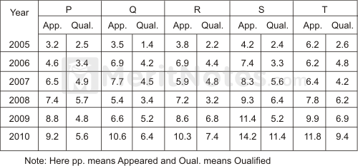

Study the given table carefully and answer the questions that follow.  
**32 Question**

Number of candidates appeared and qualified for a test (in hundreds) in 6 different years from 5 different zones. In which years was in zones the difference between the appeared candidates and qualified candidates the second lowest?

(A) 2005

(B) 2006

(C) 2007

(D) 2008

**33 Question**

The number of candidates who qualified the test from zone R in the year 2010 was approximately what percentage of the number of candidates who appeared from zone Q in the year 2008?

(A) 132

(B) 137

(C) 142

(D) 152

**34 Question**

What was the average number of candidates appeared from zone T over all the years together?

(A) 805

(B) 810

(C) 820

(D) 830

**35 Question**

What was the ratio of the number of candidates appeared from zone P in the year 2005 to the number of candidates qualified from zone S in the year 2007?

(A) 4 : 1

(B) 4 : 3

(C) 4 : 7

(D) 9 : 4

**36 Question**

From which zone was the total number of candidates who qualified the test, the second highest in the year?

(A) P

(B) Q

(C) S

(D) T

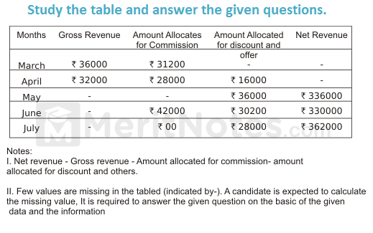

**37 Question**

In July, if 40% of the Gross revenue of the magazine was collected from advertisement, what was the amount of Gross revenue collected from advertisement in that particular month?

(A) Rs. 144000

(B) Rs. 148000

(C) Rs. 172000

(D) Rs. 182000

**38 Question**

What is the difference between Net revenue of the magazine in April and its Gross revenue in June?

(A) Rs. 118000

(B) Rs. 124000

(C) Rs. 126000

(D) Rs. 136000

**39 Question**

The area of a triangle whose sides are of lengths 3 cm, 4 cm and 5 cm is

(A) 6 cm2

(B) 8 cm2

(C) 10 cm2

(D) 12 cm2

**40 Questions**

In May, the respective ratio of amount allocated for commission and amount allocated for discount and others was 4 : 3. What was the Gross revenue of the magazine in May?

(A) Rs. 380000

(B) Rs. 420000

(C) Rs. 430000

(D) Rs. 435000

**41 Questions**

Amount allocated for commission in March is what percent less than the amount allocated for commission in July?

(A) 22%

(B) 24%

(C) 26%

(D) 28%

**42 Questions**

In March, if Net revenue of the magazine was 85% of its Gross revenue, what was the amount allocated for discount and others?

(A) Rs. 22400

(B) Rs. 22800

(C) Rs. 23200

(D) Rs. 24200

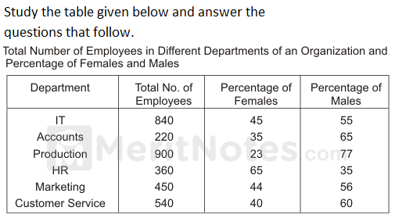

**43 Questions**

What is the respective ratio of the number of females in Production department to the number of females in the Marketing department?

(A) 22 : 23

(B) 23 : 22

(C) 33 : 35

(D) 35 : 33

**44 Questions**

What is the total number of employees in all the departments together?

(A) 3030

(B) 3140

(C) 3310

(D) 3260

**45 Questions**

The total number of employees in the HR department forms approximately what percent of the total number of employees in the Accounts department?

(A) 149%

(B) 157%

(C) 164%

(D) 178%

**46 Questions**

What is the total number of males in the IT and Customer service departments together?

(A) 687

(B) 768

(C) 786

(D) 876

**47 Questions**

What is the ratio of the number of females in the HR and the Accounts departments together to the number of males in the same department together?

(A) 268 : 311

(B) 311 : 269

(C) 319 : 268

(D) 329 : 368

**48 Questions**

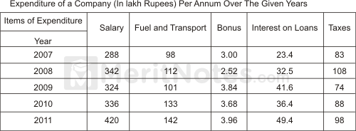

**48 Questions**

The ratio between the total expenditure on Taxes for all the years and the total expenditure of Fuel and Transport for all the years respectively, is approximately

(A) 2 : 3

(B) 4 : 7

(C) 5 : 6

(D) 10 : 13

**49 Questions**

The total expenditure of the company over these items during the year 2009 is

(A) Rs. 478.87 lakhs

(B) Rs. 501.11 lakhs

(C) Rs. 544.44 lakhs

(D) Rs. 612.13 lakhs

**50 Questions**

What is the average amount of interest per year which the company had to pay during this period?

(A) Rs. 34.18 lakhs

(B) Rs. 35.69 lakhs

(C) Rs. 36.66 lakhs

(D) Rs. 38.66 lakhs

**51 Questions**

The total number of bonus paid by the company during the given period is approximately what percent of the total amount of salary paid during this period?

(A) 0.1%

(B) 0.5%

(C) 0.7%

(D) 1%



**52 Question**

What is the respective ratio of the number of females in Production department to the number of females in the Marketing department?

(A) 22 : 23

(B) 23 : 22

(C) 33 : 35

(D) 35 : 33

**53 Question**

What is the total number of employees in all the departments together?

(A) 3030

(B) 3140

(C) 3310

(D) 3260

**54 Question**

The total number of employees in the HR department forms approximately what percent of the total number of employees in the Accounts department?

(A) 149%

(B) 157%

(C) 164%

(D) 178%

**55 Question**

What is the total number of males in the IT and Customer service departments together?

(A) 687

(B) 768

(C) 786

(D) 876

**56 Question**

What is the ratio of the number of females in the HR and the Accounts departments together to the number of males in the same department together?

(A) 268 : 311

(B) 311 : 269

(C) 319 : 268

(D) 329 : 368

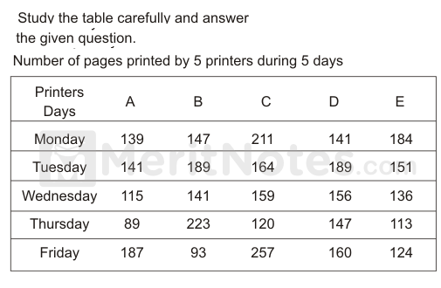

**57 Question**

What is the respective ratio between total number of pages printed by printer B on Wednesday and Thursday together and total number of pages printed C on Monday and Friday together?

(A) 7 : 9

(B) 7 : 11

(C) 9 : 11

(D) 11 : 13

**58 Question**

What is the difference between total number of pages printed by printers C and D together on Tuesday and total number of pages printed by printers A and E together on Thursday?

(A) 149

(B) 151

(C) 153

(D) 157

**59 Question**

What is the average number of pages printed by printer B on Monday, Tuesday and Friday?

(A) 138

(B) 140

(C) 141

(D) 143

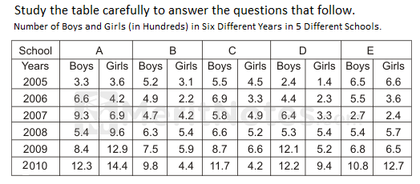

**60 Question**

What is the approximate percentage decrease in the number of boys in School D in the year 2008 as compared to that in the previous year?

(A) 5%

(B) 9%

(C) 12%

(D) 17%

**61 Question**

The number of girls in School B in the year 2009 is approximately what percent of the total number of students in School E in the year 2006?

(A) 52%

(B) 58%

(C) 60%

(D) 65%

**62 Question**

What is the average number of girls in School A in all the years taken together?

(A) 600

(B) 760

(C) 800

(D) 860

**63 Question**

What is the ratio of the number of boys in School C in the year 2009 to the number of girls in School A in the year 2009?

(A) 29: 41

(B) 29 : 43

(C) 36 : 11

(D) 36 : 13

**64 Question**

In which year is the total number of students the third highest in School E?

(A) 2005

(B) 2006

(C) 2007

(D) 2008

**65 Question**

A train 150 m long takes 20 seconds to cross a platform 450 m long. The speed of the train in (m/sec) is

(A) 20

(B) 22.5

(C) 30

(D) 40

**66 Question**

Two trains travel in opposite directions at 36 km/hr and 45 km/hr and a man sitting in slower train passes the faster train in 8 seconds. The length of the faster train is

(A) 80 m

(B) 120 m

(C) 180 m

(D) 190 m

**67 Question**

Two trains of equal length are running on parallel lines in the same direction at 46 km/hr and 36 km/hr. The faster train passes the slower train in 36 seconds. The length of each train is

(A) 40 m

(B) 50 m

(C) 60 m

(D) 72 m

**68 Question**

A man sitting in a train is counting the pillars of electricity. The distance between two pillars is 60 metres, and the speed of the train is 42 km/hr. In 5 hours, how many pillars will he count?

(A) 3500

(B) 3501

(C) 3600

(D) 3800

**69 Question**

Two trains of equal lengths take 10 seconds and 15 seconds respectively to cross a telegraph post. If the length of each train be 120 metres, in what time(in seconds) will they cross each other travelling in opposite direction?

(A) 8

(B) 10

(C) 12

(D) 16

**70 Question**

A train is moving at a speed of 132 km/hr. If the length of the train is 110 meters, how long will it take to cross a railway platform 165 m long?

(A) 5 sec

(B) 6 sec

(C) 7.5 sec

(D) 10 sec

**71 Question**

A 160 meter long train takes 30 seconds to cross a platform. What is the speed of the train?

(A) 80 km/hr

(B) 90 km/hr

(C) 100 km/hr

(D) Data inadequate

**72 Question**

A train of length 150 meters takes 10 seconds to pass over another train 100 meters long coming from the opposite direction. If the speed of the first train be 30 km/hr, the speed of the second train is

(A) 54 km/hr

(B) 58 km/hr

(C) 60 km/hr

(D) 72 km/hr

**73 Question**

A train moves with a speed of 108 kmph. Its speed in metres per second is

(A) 10.8 m/sec.

(B) 18 m/sec.

(C) 28 m/sec.

(D) 30 m/sec.

**74 Question**

A man is watching from the top of a tower a boat speeding away from the tower. The boat makes an angle of depression of 45° with the man’s eye when at a distance of 60 metres from the tower. After 5 seconds, the angle of depression becomes 30°. What is the approximate speed of the boat, assuming that it is running in still water?

(A) 32 kmph

(B) 36 kmph

(C) 38 kmph

(D) 42 kmph

**75 Question**

In how many different ways can the letters of the word ‘GAMBLE’ be arranged?

(A) 120

(B) 240

(C) 720

(D) 840

**76 Question**

In how many different ways can the letters of the word ‘SMART’ be arranged?

(A) 60

(B) 120

(C) 180

**(D) 240**

**77 Question**

In how many different ways can the letters of the word ‘TOTAL’ be arranged?

(A) 40

(B) 50

(C) 60

(D) 80

**78 Question**

In how many different ways can the letters of the word ‘DAILY’ be arranged?

(A) 60

(B) 120

(C) 180

(D) 240

**79 Question**

In how many different ways can the letters of the word ‘AWARE’ be arranged?

(A) 40

(B) 60

(C) 120

(D) 150

**80 Question**

On 8th February, 1995 it was Wednesday. The day of the week on 8th February 1994 was

(A) Tuesday

(B) Wednesday

(C) Thursday

(D) Monday

**81 Question**

India got independence on August 15, 1947. What was the day of the week?

(A) Monday

(B) Friday

(C) Thursday

(D) Sunday

**82 Question**

A clock is set right at 5 am. The clock loses 16 minutes in 24 hours. What will be the true time when the clock indicates 10 pm. On the 4th day?

(A) 9 am

(B) 11 pm

(C) 11 am

(D) 9 pm

**83 Question**

My watch gains 5 seconds in 3 minutes was set right at 7 a.m. In the afternoon of the same day, when the watches indicates quarter past 4 o’clock, the true time is

(A) 4 pm

(B) 5 pm

(C) 6 pm

(D) 7 pm

**84 Question**

The first Republic Day of India was celebrated on January 26, 1950. What was the day of the week on that date?

(A) Monday

(B) Wednesday

(C) Thursday

(D) Saturday

**85 Question**

How many days are there from 2nd January 1995 to 15th March 1995?

(A) 71

(B) 72

(C) 73

(D) 74

**86 Question**

The year next to 1996 having the same calendar as that of 1996 is

(A) 2001

(B) 2002

(C) 2003

(D) 2004

**87 Question**

Find out the wrong number in each sequence:  
16, 32, 64, 81, 100, 144, 190

(A) 36

(B) 81

(C) 100

(D) 190

**88 Question**

Find out the wrong number in each sequence:  
22, 33, 69, 99, 121, 279, 594

(A) 594

(B) 279

(C) 121

(D) 33

**89 Question**

Find out the wrong number in each sequence:  
10, 14, 28, 32, 64, 68, 132

(A) 28

(B) 32

(C) 68

(D) 132

[r](https://meritnotes.com/aptitude/odd-man-series/1-78041/#collapseThree3)

**90 Question**

Find out the wrong number in each sequence:  
1, 8, 27, 64, 124, 216, 343

(A) 8

(B) 27

(C) 64

**(D) 124**

**91 Question**

Find out the wrong number in each sequence:  
105, 85, 60, 30, 0, - 45, - 90

(A) 85

(B) 60

(C) -45

**92 Question**

Find out the wrong number in each sequence:  
8, 13, 21, 32, 47, 63, 83

(A) 32

(B) 47

(C) 63

(D) 83

**93 Question**

Insert the missing number:  
16, 33, 65, 131, 261, (…..)

(A) 721

(B) 613

(C) 523

(D) 521

**94 Question**

Insert the missing number:  
8, 7, 11, 12, 14, 17, 17, 22, (…..)

(A) 20

(B) 22

(C) 24

(D) 27

**95 Question**

Insert the missing number:  
9, 12, 11, 14, 13, (…..), 15

(A) 10

(B) 12

(C) 16

(D) 17

**96 Question**

Insert the missing number:  
2, 6, 12, 20, 30, 42, 56, (…..)

(A) 60

(B) 64

(C) 70

(D) 72

**97 Question**

Insert the missing number:  
2, 4, 12, 48, 240, (…..)

(A) 1920

(B) 1440

(C) 1080

(D) 960

**98 Question**

Insert the missing number:  
16, 33, 65, 131, 261, (…..)

(A) 521

(B) 523

(C) 613

(D) 721

**99 Question**

If a clock takes 22 seconds to strike 12, how much time will it take to strike 6?

(A) 10 seconds

(B) 12 seconds

(C) 14 seconds

(D) 16 seconds

**100 Question**

How often are the hands of a clock at right angle every day?

(A) 38 times

(B) 40 times

(C) 44 times

(D) 48 times

**Answer keys**

1. **Answer: - B) 50 thousand**
2. **Answer: C) 48.72%**
3. **Answer:- D) 40%**
4. **Answer: - B) 137.5**
5. **Answer: - B) 3:2**
6. **Answer: - C) 20%**
7. **Answer: - C) 10%**
8. **Answer:- A) 60 thousand**
9. **Answer:- B) 45.12%**
10. **Answer: - C) 30%**
11. **Answer: - A) 162.5**
12. **Answer: - A) 3:5**
13. **Answer: - C) 20%**
14. **Answer: - B) 10%**
15. **Answer Key: E**
16. **Answer Key: E**
17. **Answer: D. 0.202**
18. **Answer: A**
19. **Answer: 0.302**
20. **Answer: - A) 162.5**
21. **Answer: - A) 3:5**
22. **Answer: - C) 20%**
23. **Answer: - B) 10%**
24. **Answer: B**
25. **Ans: D**
26. **Ans: C**
27. **Ans: A**
28. **Ans: C**
29. **Ans: B**
30. **Ans: B**
31. **Ans: C**
32. **Ans: C**
33. **Ans: B**
34. **Ans: A**
35. **Ans: C**
36. **Ans: D**
37. **Ans: C**
38. **Ans: C**
39. **Ans: A**
40. **Ans: B**
41. **Ans: A**
42. **Ans: B**
43. **Ans: B**
44. **Ans: C**
45. **Ans: C**
46. **Ans: C**
47. **Ans: B**
48. **Ans: D**
49. **Ans: C**
50. **Ans: C**
51. **Ans: D**
52. **Ans: B**
53. **Ans: C**
54. **Ans: C**
55. **Ans: C**
56. **Ans: B**
57. **Ans: A**
58. **Ans: B**
59. **Ans: D**
60. **Ans: D**
61. **Ans: D**
62. **Ans: D**
63. **Ans: B**
64. **Ans: B**
65. **Ans: C**
66. **Ans: C**
67. **Ans: B**
68. **Ans: B**
69. **Ans: C**
70. **Ans: C**
71. **Ans: D**
72. **Ans: C**
73. **Ans: D**
74. **Ans: A**
75. **Ans: C**
76. **Ans: B**
77. **Ans: C**
78. **Ans: B**
79. **Ans: B**
80. **Ans: A**
81. **Ans: B**
82. **Ans: B**
83. **Ans: A**
84. **Ans: C**
85. **Ans: C**
86. **Ans: A**
87. **Ans: D**
88. **Ans: B**
89. **Ans: D**
90. **Ans: D**
91. **Ans: D**
92. **Ans: B**
93. **Ans: C**
94. **Ans: A**
95. **Ans: C**
96. **Ans: D**
97. **Ans: B**
98. **Ans: B**
99. **Ans: A**
100. **Ans: C**